HANOI UNIVERSITY OF SCIENCE AND TECHNOLOGY

School of Information and communications technology



Network Programming

Capstone Project Report

**P2P CHAT APPLICATION**

**Group 13**

Nguyen Duc Hung – 20176779

Nguyen Manh Khang – 20176792

*Hanoi, June, 2021*

Table of Contents

**Introduction** **2**

P2P Chat Application 2

Network programming techniques 3

**Architectural Design** **3**

UseCase 3

Basic flow of the program 4

Interaction Diagram 5

**Data Modeling** **8**

Structure to manage user 8

Linked list struct for onlineLst and chatLst 9

Structure to manage chat message 9

Structure to exchange message over network 10

**Message Exchange Model** **11**

Functions to send and receive message over the network 11

Serialize/Deserialize functions 11

**Client & Server Design** **12**

Server Prototype 12

Client Prototype 12

**GRAPHICAL USER INTERFACE** **14**

Login Screen 14

Register Screen 15

Online List Screen 16

Chat Screen 17

Login Fail Dialog 18

Request Chatting Dialog 20

Response Dialog 21

Register Success Dialog 22

**Work Contributions** **22**

# Introduction

## P2P Chat Application

P2P chat application is a program that allows users to communicate with each other conveniently, privately and directly through the p2p protocol. This application supports functions such as creating an account, logging in, viewing a list of people who are online at the same time, and most prominently, the ability to communicate one-to-one directly with all people who are online.

Basically, a p2p chat application has two main components: a server and a client. The server, in this model, can also be called a tracker with the main role of maintaining and updating the list of users who are online, managing logins, registrations and managing user status (online, offline, lock). ).

The client, which basically represents the user, in addition to using the features provided by the server, can select the online user from the list to do a one-on-one chat in a chat window individually. This one-to-one communication has absolutely no support from the server, but rather through the p2p protocol for clients to communicate directly with each other using IP and port information previously provided by the server.

About the communication between server and client, (visually shown in the figure below), every 2s, the client side will send HI message by UDP to the server, if after 8s the server does not receive any HI message from one specific user, the server will remove that user from the online list. Every 10 seconds, the user will send a request to the tracker asking for an online list via TCP, and the server sends back an online list with info including (name, ip:port). When getting the ip port. of the user that needs to chat, user 1 will send a connection request to user 2 to proceed with the chat, user 2 can reject the request.

|  |
| --- |
|  |
| *Figure 1.1: brief model of system* |

## Network programming techniques

In this program we used the networking techniques listed below:

* TCP, UDP protocol
* Multithreading:
  + Used by peers to serve multiple other peers at a time (chat feature)
* Multiplexing:
  + Used in opening a listen socket in tracker and peers to receive and handle message
* Non-blocking IO:
  + Used when receive request message, then the peer is not blocked by waiting for receiving message from other peers. In addition, we can receive Cancel operation from user and receiving response message at the same time

# Architectural Design

## UseCase

First of all, the following is the Use Case diagram of our P2P chat application:

|  |
| --- |
|  |
| *Figure 2.1. Use case Diagram* |

Based on the diagram, the main actor user can perform the following use cases: register, login, view online list, request for chatting, response request for chatting, view chat, chat 1-1 with multiple users

## Basic flow of the program

The basic flow of our application is shown as the figure below. In this diagram, we focus on the main flow of the program and do not care too much about the alternative flow.

From the start, the user will enter the username and password, and the client will send this authentication information to the server. Server will authenticate it, if the information is correct, the server will return a certificate token and send it back to the client. When the client receives the order, it will transitive to the next screen, which is the Online list screen and also request the server for the list of online users. When the screen is displayed, the user can see other online users and can select 1 to chat. After that, the client will send the request to the targeted user ( via IP:port provided before by the server) and show the dialog that the application is sending the request to this targeted user and waiting for his/her response. When everything is done, the application will create a new chat window for the user to chat 1-1 with the targeted user.

|  |
| --- |
| *Figure 2.2. Activity Diagram* |

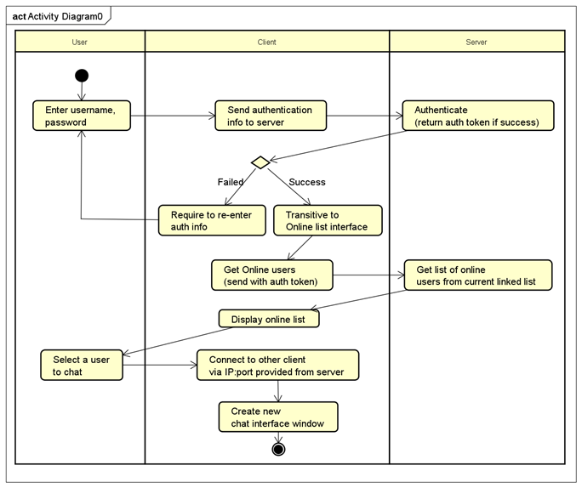

## Interaction Diagram

To have a better look into the dynamic architectural design of the software, we come up with interaction diagrams of the application:

|  |
| --- |
|  |
| *Figure 2.2. Login interaction diagram* |

In this part of the diagram, first of all, the user will submit the login information to the Client TCP main thread, this thread will create a Client TCP revc message thread for binding this user to 1 available port, and also send the information to the Server TCP logic thread. The Server TCP logic thread will authenticate the information, add this user to the list of online users, and send back certificate token to the Client TCP main thread. When receiving the token, the Client TCP main thread will create 2 more threads, which are Client UDP tracking thread and Update Online List thread for sending Hi message and token to the server every 2s and getting the online list periodically 10s, respectively.

|  |
| --- |
|  |
| *Figure 2.3. Chatting interaction diagram* |

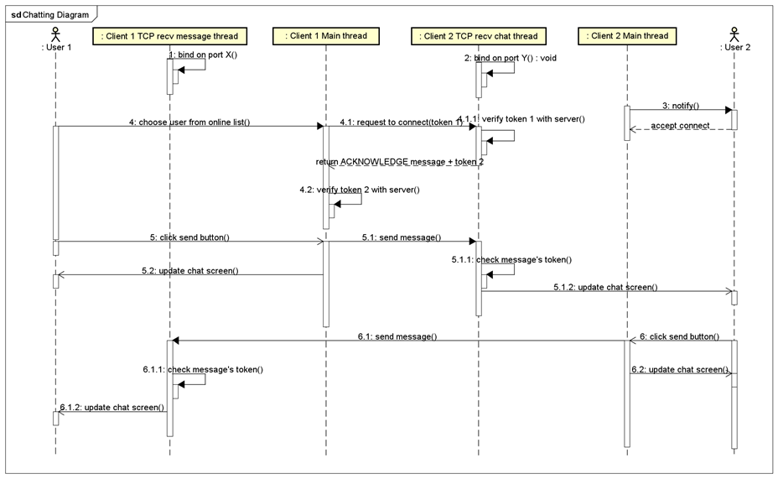

In this diagram, we can see the sequence of chatting flow after successfully login. We have 2 users showing up in this diagram. For instance, user1 will request user2 for chatting.

After logging in, 2 users are bonded to 2 available ports X and Y (this part is shown before in the login diagram and done by Client TCP recv message thread). When user1 select user 2 to connect, the Client 1 main thread will create a request message contains user1’s certificate token, this message is sent to Client 2 TCP recv message thread, in this thread, user1’s token will be verified, if success, Client 2 main thread will notify and ask for answer from user 2 (pop up 1 dialog). If the request is accepted, Client 2 main thread will send the response and user2's token to Client 1 main thread. After that, 2 users will redirect to a new separate window for 1-1 chatting.

For chatting, when 1 user clicks the send button, this Client Main thread will send the chat message to the other user Client TCP recv message thread, and will update the screen in both 2 users.

# Data Modeling

## Structure to manage user

* usr : username
* pwd : password
* token : for authentication
* usrAddr : address of peer
* status : account status (see below)
* logCnt : login attempt count
* offCnt : offline interval time count

The code for the struct user will be shown below:

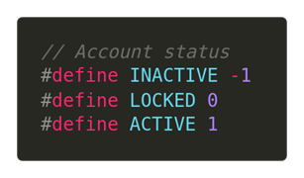

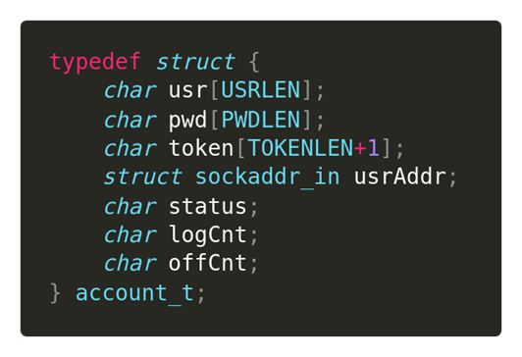

## Linked list struct for onlineLst and chatLst

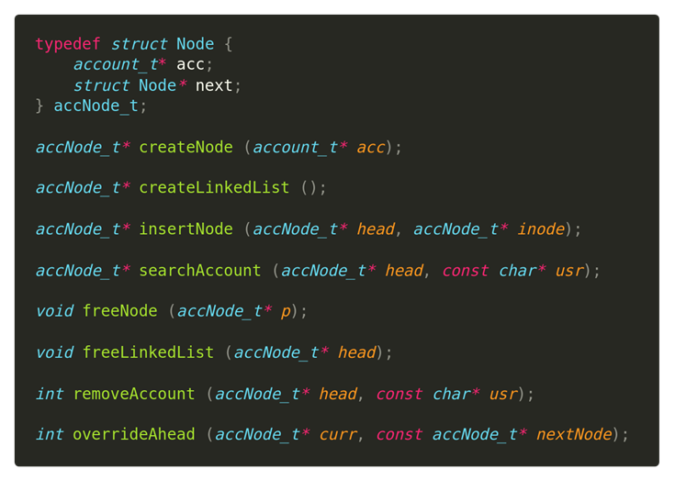

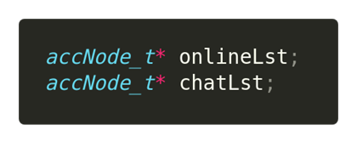

## Structure to manage chat message

* from : username of sender
* token : token of sender
* to : username of receiver
* txt : chat message
* at : send time

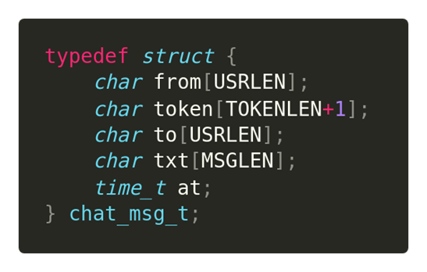

## Structure to exchange message over network

* type : message type
* len : payload length
* payload : message content

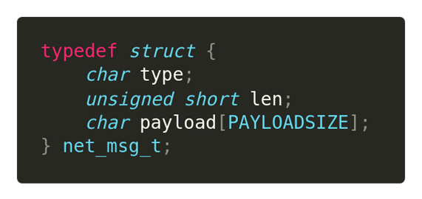

## 

# Message Exchange Model

## Functions to send and receive message over the network

* sendMsg : caller prepares net_msg_t message to send through sockfd
* recvMsg : caller have to allocate space for storing network message read in sockfd

.

|  |
| --- |
|  |
| *Figure 4.1. sendMsg and recvMsg function* |

## Serialize/Deserialize functions

* We need to turn an chat message structure into a buffer to store in net_msg_t.payload, and a network message structure into a memory buffer for easily exchange over network -> solution: serialize at sender, deserialize at receiver
* Serialize : convert message structure (which is organized by C structure standard) into a formatted memory buffer (which can send through over network without worrying about memory padding)
* Deserialize : convert a formatted memory buffer into allocated data structure

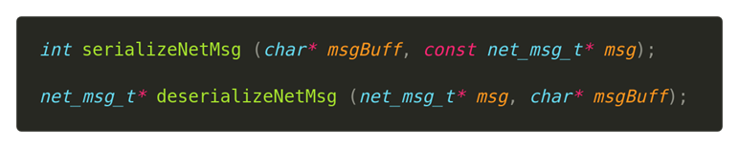

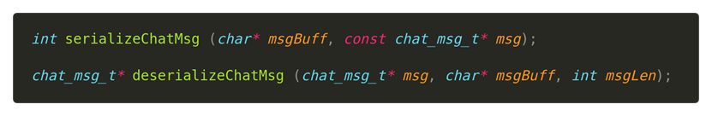

|  |
| --- |
|  |
|  |

# Client & Server Design

## Server Prototype

* startServer: bind and listen to a port
* processLogic: receive and handle message (authenticate message, get online list message)
* maintainOnlineLst: run on a separate thread to manage online list each time interval
* hiMsgTracking: run on a separate thread to receive HI message each time interval

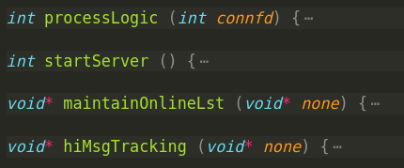

## Client Prototype

* sendHIMsg: run on a separate thread to send HI msg each time interval
* updateOnlineLst: run on a separate thread to retrieve online list each time interval
* sendChatMsg: run on a separate thread to send chat message
* clientMsgHandler: run on separate thread to receive control message
* clientMsgReceiver: run on the same thread with clientMsgHandler (called by clientMsgHandler to read and handle control message)
* connectChat: run on a separate thread to request connect to other client
* showOnlineList: run on main thread to show online list (called by loginSuccess)

loginSuccess: run on main thread to prepare things when login success (called by login)

Login: run on main thread to do authentication

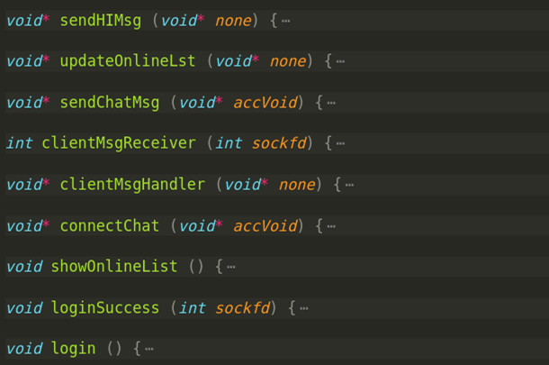

# GRAPHICAL USER INTERFACE

## Login Screen

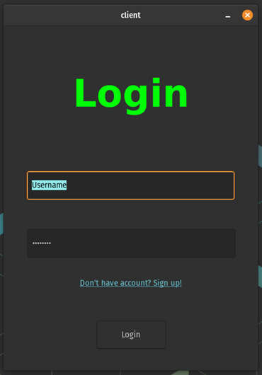

## Register Screen

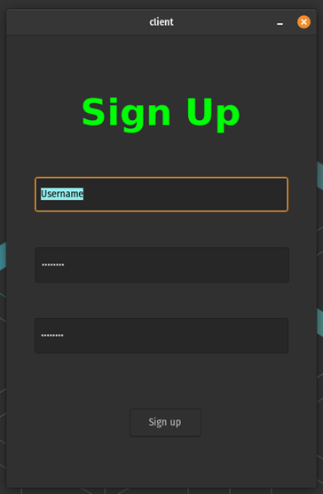

## Online List Screen

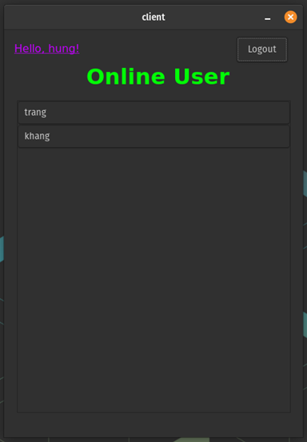

## Chat Screen

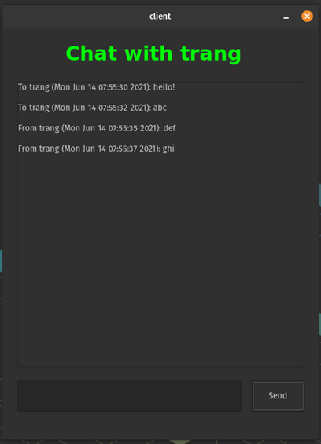

## Login Fail Dialog

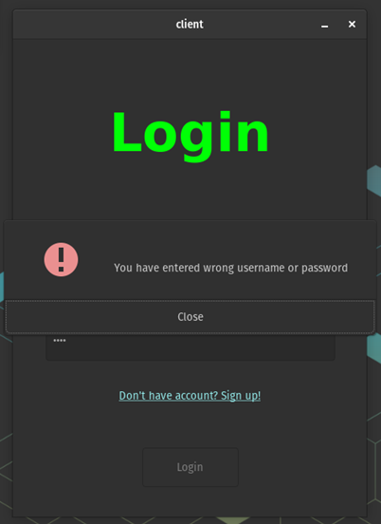

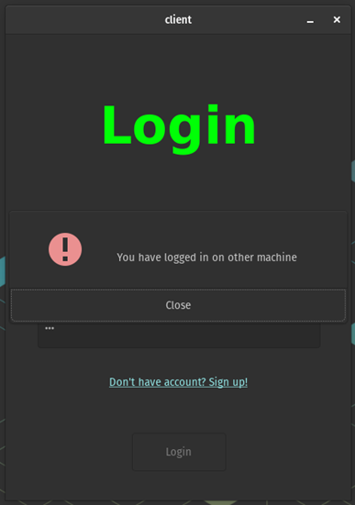

## Request Chatting Dialog

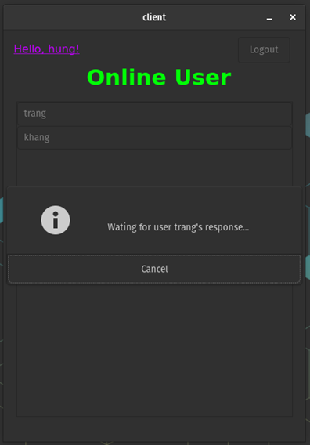

## Response Dialog

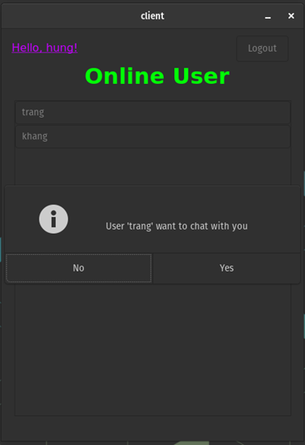

## Register Success Dialog

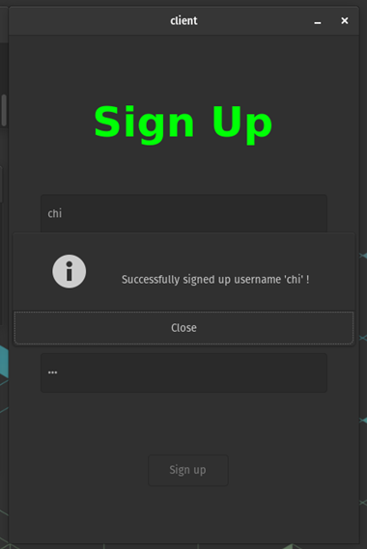

# Work Contributions

|  |  |  |  |  |
| --- | --- | --- | --- | --- |
| Work | Code Base | Interface | Presentation, Report | Architectural Design |
| Hưng | 60% | 40% | 30% | 70% |
| Khang | 40% | 60% | 70% | 30% |